ITSE FINAL PROJECT

PROJECT NAME:

FITNESS MANAGEMENT SYSTEM

NAME: ALI ABBAS

ROLL NUMBER: 23F-3037.

HOMEPAGE: 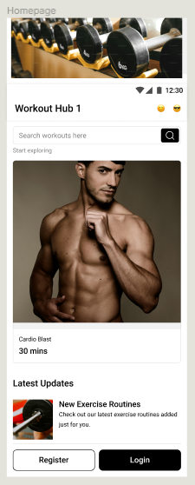

**USER**-PROFILE

USER-PROFIL: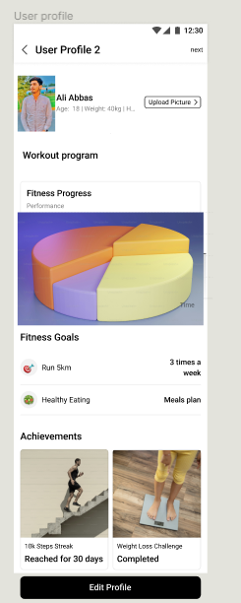

WORKOUT PROGRAM:



NUTRITION PROGRAM:

WORKOUT LIBRARY:

SETTING:

FEEDBACK AND ABOUT US:

LOGOUT:

**1. Document:**

**2. General Information**

**Purpose:**

The purpose of this project is to design and prototype a user-friendly Fitness Management System app that helps individuals track their fitness goals, manage workout routines, monitor nutrition, and visualize progress.

**Scope:**

The scope of the project involves designing a responsive and intuitive app interface accessible on multiple devices. The app will allow users to create personalized profiles, set fitness goals, receive workout recommendations, track dietary intake, and view progress reports.

**Overview**

**Project Type:**

This project involves designing a fitness management app using Figma, focusing on user interface and user experience design.

**Development Stage:**

The development stage will primarily focus on creating wireframes, prototypes, and design assets within Figma. This includes defining user flows, designing screens, and creating interactive prototypes.

**Constraints**

* **User-Centric Design:**

Emphasis on creating an intuitive and visually appealing interface to cater to users of all fitness levels.

* **Design Consistency:**

Maintain consistency in design elements, typography, and color scheme throughout the app.

* **Prototype Interactivity:**

Utilize Figma's interactive features to demonstrate app functionality and user interactions.

* **Features:**

The Fitness Management System app will incorporate the following key features in the design.

* **User Onboarding:**

Seamless registration and onboarding process.

* **Personalized Profiles:**

Customizable user profiles with fitness goals and preferences.

* **Goal Setting and Tracking:**

 Interactive goal-setting interface with progress tracking.

* **Workout Recommendations:**

Display workout routines based on user preferences.

* **Nutrition Tracking:**

 Interface for inputting and monitoring dietary intake.

* **Progress Visualization:**

 Charts and graphs showcase fitness progress and achievements.

**Time Required:**

The estimated time for designing and prototyping the app using Figma is approximately 2 months, allowing for iterative design improvements and feedback.

**3. Feasibility**

**Users:**

The target users for the Fitness Management System app include fitness structured fitness guidance.

**Operational:**

The app will be designed for optimal performance across various devices and screen sizes, ensuring a consistent and responsive user experience.

**4. Tools**

The project will utilize the following tools and resources for designing the app:

* **Figma:** Main platform for creating wireframes, designs, and interactive prototypes.
* **Feedback and Collaboration:** Gather feedback and iterate on designs through Figma's collaboration features.